1. Problem Statement
Develop a beginner-friendly menu-driven program that integrates student records, attendance tracking, and simple summary reporting using loops and conditional statements.
2. Objectives
- Implement a continuous while loop with a text menu for user selections.
- Use basic lists and conditional statements to manage mock campus data.
3. Algorithm
- Start.
- Display a menu with choices: View Students, Add Student, Check Attendance, Exit.
- Read user choice using input().
- Use if-elif-else to execute the selected choice.
- Repeat until the user chooses to exit.
- Stop.
4.Flowchart
[Start]
--> [Set is_running = True and initialize student list]
--> [While is_running == True:]
--> [Display Campus Menu Options (1 to 4)]
--> [Read User Choice]
--> {Evaluate Choice}
├── Choice 1 (View) --> [Loop and print student list]
├── Choice 2 (Add) --> [Read new name and append to list]
├── Choice 3 (Count) --> [Print total item count of list]
└── Choice 4 (Exit) --> [Set is_running = False]
--> [Stop]
5. Pseudocode
START
running = TRUE
students = ["Rahul", "Sneha", "Amit"]

WHILE running == TRUE DO
PRINT "1. View Students\n2. Add Student\n3. Exit"
READ choice
IF choice == 1 THEN
PRINT students
ELSE IF choice == 2 THEN
PRINT "Enter new name:"
READ new_name
ADD new_name TO students
ELSE IF choice == 3 THEN
running = FALSE
ELSE
PRINT "Invalid choice"
ENDIF
ENDWHILE
STOP
6. Python Source Code
print("=== Smart Campus Management System ===")

student_list = ["Rahul Sharma", "Priya Patel", "Amit Kumar"]

is_running = True

while is_running:
print("\n--- CAMPUS MENU ---")
print("1. View All Students")
print("2. Add New Student")
print("3. Count Total Students")
print("4. Exit Simulation")

choice = input("Enter your choice (1-4): ")

if choice == '1':
print("\nList of Registered Students:")
index = 1
for student in student_list:
print(index, ".", student)
index = index + 1

elif choice == '2':
new_student = input("Enter full name of new student: ")
student_list.append(new_student)
print("Success! Added", new_student, "to the system.")

elif choice == '3':
print("\nTotal number of students currently registered:", len(student_list))

elif choice == '4':
print("\nExiting Smart Campus System. Have a great day!")
is_running = False

else:
print("\nInvalid choice! Please enter a number between 1 and 4.")
7. Test Cases & Output Log
- Test Case: Select option 1 (View), Option 2 (Add "Neha"), Option 3 (Count), Option 4 (Exit).
- Log:
=== Smart Campus Management System ===
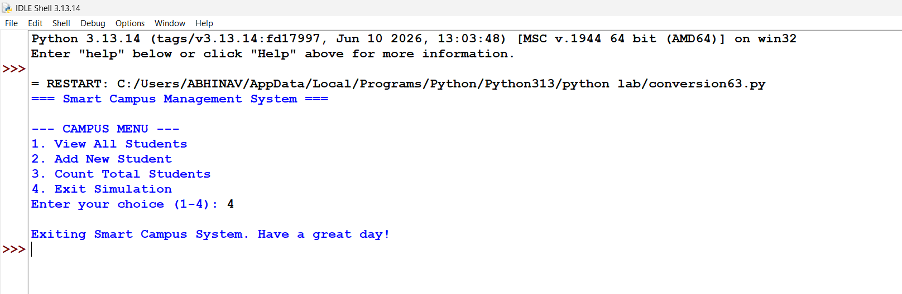
Conclusion: Successfully integrated multiple core concepts—including menus, loops, conditional statements, and dynamic lists—into a cohesive, menu-driven smart campus simulation tool.

